GRPC - Demystifying gRPC(Intro to gRPC) with Spring Boot.

Reference Links

Official Documentation & First-Party Guides: -
https://docs.spring.io/spring-boot/4.1-SNAPSHOT/reference/io/grpc.html
https://docs.spring.io/spring-grpc/reference/index.html
https://protobuf.dev/getting-started/javatutorial/
https://mojoauth.com/grpc/use-grpc-with-spring-boot#setting-up-your-grpc-service

In-Depth Technical Blogs :-
https://www.baeldung.com/spring-boot-grpc
https://somindagamage.medium.com/spring-boot-for-beginners-grpc-with-spring-boot-9de4ae2a0937
https://medium.com/@javatechie/protobuf-protocol-buffers-a-simple-introduction-c224bf10f826
https://medium.com/@dinesharney/building-a-simple-grpc-client-and-server-with-spring-boot-3-4672c1e4fab7
https://blog.vinsguru.com/grpc-tutorial-java/

Youtube links :-
https://www.youtube.com/playlist?list=PLVz2XdJiJQxw0f6wXQCdWKabLdqSzGA0X
https://www.youtube.com/playlist?list=PL1F54YqZCTdxpGWMM7zyOigOQ_MVwSNc2

Topics of Discussion

Q: What is gRPC?
gRPC (which stands for gRPC Remote Procedure Call) is a modern, high-performance, open-source framework developed by Google.
At its core, gRPC allows a client application to directly call a method on a server application located on a different machine as if it were a local object function call. It completely abstracts away the networking plumbing, making it significantly easier to build highly efficient, distributed microservices.

Q: How gRPC leverages HTTP/2 and Protocol Buffers to provide low-latency, strongly-typed communication between microservices ?
The Two Core Pillars of gRPC
gRPC achieves its extreme speed and efficiency by combining two distinct technologies:
1. Protocol Buffers (Protobuf) as the Data Format
Instead of text-based formats like JSON or XML used in traditional REST APIs, gRPC uses Protocol Buffers (usually .proto files) as both its Interface Definition Language (IDL) and its message serialization format.
- Contract-First: You define your data structures (message) and your API functions (service) in a .proto file.
- Code Generation: You run this file through the Protobuf compiler (protoc), which automatically generates strongly typed client stubs and server base classes in almost any programming language (Java, Go, Python, C++, etc.).
- Binary Serialization: Data is translated into a highly compressed, optimized binary format before being sent over the wire, making the payloads significantly smaller and faster to parse than JSON.
2. HTTP/2 as the Transport Protocol
Traditional REST APIs are largely bound to HTTP/1.1. gRPC requires HTTP/2, which unlocks immense performance capabilities:
- Multiplexing: Multiple requests and responses can be sent concurrently over a single TCP connection, eliminating the "head-of-line blocking" issue found in HTTP/1.1.
- Bidirectional Streaming: Both the client and the server can stream data back and forth simultaneously over a long-lived connection.
- Header Compression: HTTP/2 compresses large request and response headers, cutting down execution overhead on every call

Q: High level architecture of gRPC client-server application ?
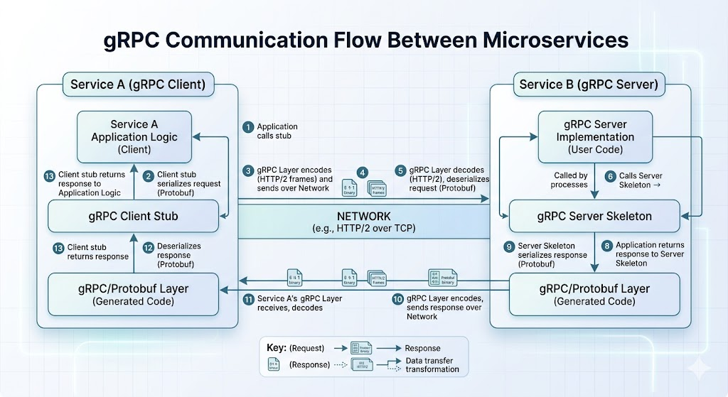

Q: Different communication patterns in gRPC ?

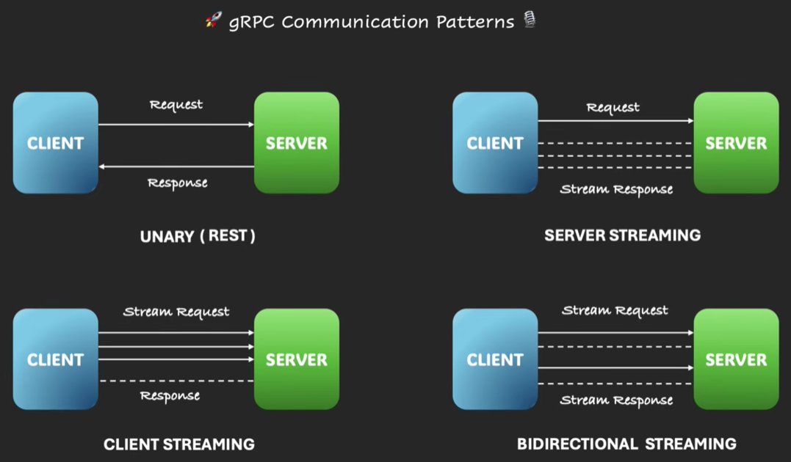
The 4 Communication Paradigms
Unlike REST, which is strictly restricted to a single Request -> Single Response model, gRPC supports four distinct communication patterns out of the box:
- Unary RPC (The Classic Call): The client sends a single request message and receives a single response from the server, just like a standard desktop function call or a REST request.
- Server Streaming RPC: The client sends one request message, and the server opens a stream to send back a sequence of multiple response messages (e.g., streaming a real-time feed of stock market prices).
- Client Streaming RPC: The client sends a continuous stream of multiple request messages, and once done, the server processes them and returns a single summary response (e.g., uploading a large data file in chunks).
- Bidirectional Streaming RPC: Both the client and the server send a stream of messages independently and concurrently over a single connection. The streams operate completely asynchronously.

Q: Comparison between gRPC and REST ?
Feature | gRPC | REST
Protocol | HTTP/2 exclusively | Typically HTTP/1.1
Payload Format | Protobuf (Binary, compressed) | JSON or XML (Plain text)
Design Style | Service/Action-oriented (getUser()) | Resource-oriented (GET /users/1)
Streaming | Supports 4 modes (Unary, Client, Server, Bidi) | Limited to Unary (Request/Response)
Coupling | Tightly coupled via shared .proto contracts | Loosely coupled
Code Generation | In-built and native (protoc) | Requires third-party tools (Swagger/OpenAPI)

Q: JSON format vs ProtoBuf - Payload structure comparision?
Example-1:
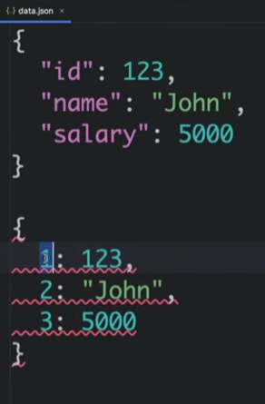

Example-2:
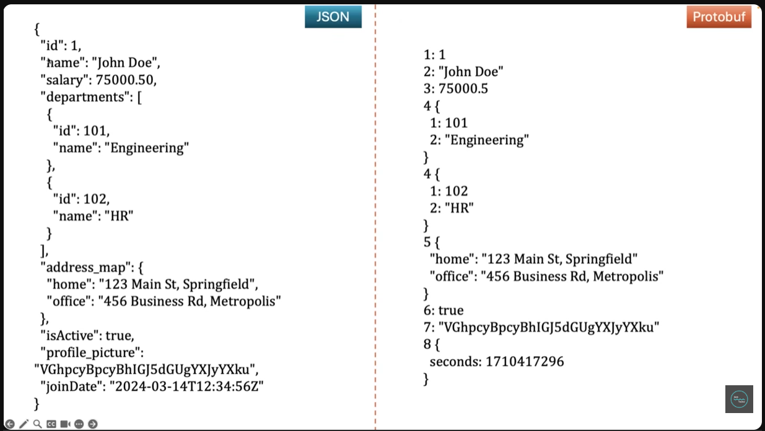

Q: When to use ?
- Microservice-to-Microservice Communication: It is highly optimized for internal backend architectures where low latency and high throughput are critical.
- Polyglot Environments: If your company uses Java for the core backend, Go for infrastructure tools, and Python for data processing, gRPC generates native code for all three, letting them talk seamlessly.
- Real-time Streaming: Ideal for systems that require instant, ongoing data transfers, such as chat applications, telemetry tracking, or IoT sensor connections.
- Network-Constrained Environments: Since the payload is compressed binary, it uses far less bandwidth, making it great for mobile apps or remote devices.

Q: When not to use gRPC?
While gRPC is an exceptional framework for high-performance microservice-to-microservice communication, it is not a silver bullet. Choosing it for the wrong usecase can introduce massive architectural friction, debugging headaches, and unnecessary deployment complexity.
Here are the scenarios where you should avoid using gRPC, and what you should use instead.
1. Public-Facing APIs (External Integrations)
If you are exposing an API to external third-party developers, partners, or the public digital economy, gRPC is generally a poor choice.
- Why: gRPC forces a tightly-coupled, contract-first design. To consume your API, external developers must have your exact .proto files, install specific compilers (protoc), and generate code stubs in their own applications.
- The Friction: If an external partner uses an interpreted language with weaker gRPC tool maturity, integrating with your service becomes a massive chore. Furthermore, breaking changes in the contract require tightly coordinated updates.
- What to use instead: REST (with OpenAPI/Swagger) or GraphQL. REST is universally understood, decoupled, self-descriptive, and works out of the box with standard HTTP libraries in every single language on earth.
2. Direct Browser-Based Frontend Web Applications
Native gRPC relies heavily on low-level HTTP/2 features—specifically HTTP/2 framing and HTTP Trailers (headers sent after the response body, which gRPC uses to pass status codes and error flags).
- Why: Modern web browsers (Chrome, Safari, Firefox) simply do not expose fine-grained control over HTTP/2 frames or trailers via standard browser APIs like Fetch or XHR.
- The Overkill: To make gRPC work in a browser, you must implement gRPC-Web, which forces you to spin up and maintain an intermediate proxy layer (like an Envoy Proxy) to translate incoming browser requests into native backend gRPC. This adds a brand-new single point of failure and infrastructure overhead just to handle simple UI requests.
- What to use instead: REST for classic CRUD actions, or GraphQL if your frontend needs to aggregate data from multiple backend sources without over-fetching.
3. High-Caching Systems (Content Delivery Networks)
If your application depends heavily on caching repetitive edge data (like product catalogs, public user profiles, or static asset metadata) via a CDN like Cloudflare or Akamai, gRPC will break this model.
- Why: Under the hood, all gRPC requests are sent as HTTP POST requests. By architectural design, edge networks and standard HTTP proxies do not cache POST requests. Furthermore, because the payload traveling inside the connection is compressed binary Protobuf data, network intermediaries cannot peek into the payload to inspect cache keys or apply routing rules based on text parameters.
- What to use instead: REST APIs using HTTP GET methods. This allows standard caching headers (Cache-Control, ETag) to optimize network traffic cleanly at the CDN edge.
4. Simple CRUD Applications and Micro-Projects
If you are building a small, internal application or a straightforward internal tool whose only function is basic database CRUD operations (Create, Read, Update, Delete) without intensive computation or real-time streaming:
- Why: Setting up gRPC requires establishing build-time automation plugins, organizing multi-module architectures to share .proto files safely, managing specialized local load balancers, and learning specialized syntax. For a simple app, this results in an architecture where the boilerplate overhead drastically outweighs the actual business logic code.
- What to use instead: REST (via Spring Boot Web). It's fast to write, instantly deployable, and requires zero initial build-step configurations.
5. Teams without Deep Technical Infrastructure Experience
Because gRPC payloads are compressed binary, they are entirely non-human readable on the wire.
- Why: You cannot simply fire up a terminal and run curl http://localhost:8080/my-endpoint or hit F12 in your browser to debug a failing API payload. Teams must adopt specialized tools like Postman (with gRPC support), grpcurl, or implement gRPC Server Reflection.
- Operational Hurdles: Standard network infrastructure components, cloud access logs, and older Layer 7 load balancers (like classic AWS ALBs without explicit HTTP/2 target group setups) often struggle to load-balance persistent, long-lived gRPC connections natively, requiring client-side load balancing or advanced service meshes (like Linkerd or Istio).

Q: Technical Questions:

Q: What is gRPC application default port ?
Environment / Framework | Default Port | Underlying Server
Standard Google gRPC Specification | 50051 | Netty / Language Native
Spring Boot Standalone Starter | 9090 | Standalone Embedded Netty
Spring Boot Web Multiplexed Starter | 8080 | Embedded Tomcat / Jetty
Production Cloud / Public APIs | 443 | Managed Load Balancer (TLS)

Q: Defining messages and services using .proto files.
Code link to be shared for reference.

Q: Data types and mapping with rest.
Proto Type | Java Type | Notes
double | double | 64-bit floating point
float | float | 32-bit floating point
int32 | int | Uses variable-length encoding (varint)
int64 | long | Standard for large integers
bool | boolean | Stores true/false
string | String | Must contain UTF-8 or 7-bit ASCII
bytes | ByteString | Used for raw binary data
repeated | List<T> | Represents arrays or collections in Java
map<K, V> | Map<K, V> | Key-value pairs

Q: Protocol Buffers & Code Generation / Writing and compiling Protobuf definitions.
Code link to be shared for reference.

Q: Configuring a Spring Boot application as a gRPC provider/consume
Code link to be shared for reference.

Q: How can we send gRPC requests from CLI (grpcurl)?
Because gRPC relies on binary payloads serialized through Protocol Buffers via HTTP/2, you cannot use classic terminal utilities like curl out of the box.
Instead, the industry standard for interacting with gRPC servers via the command line is grpcurl (created by FullStory). It acts exactly like curl, but is designed specifically for gRPC channels.
Ref: How can we send gRPC requests from CLI.docx

Q: Which tools can be used for sending and receiving gRPC requests and responses?
Testing and debugging gRPC applications requires specialized tooling because payloads are compressed binary (Protobuf) rather than human-readable text.
1. Graphical User Interface (GUI) Clients
If you prefer a visual dashboard similar to traditional REST workflows where you can click buttons, view execution times, and save collections of requests, these are the best choices:
Postman (Most Popular)
- Key Features: You can load .proto files directly or use gRPC Server Reflection to dynamically discover endpoints. It provides autocomplete hints when typing your request JSON payload, supports scripts for pre-request/post-response validation, and seamlessly handles all 4 gRPC streaming types.
Kreya
- Key Features: Kreya stands out for its excellent environment configurations and mock data generation features. Its configuration files are entirely file-system-based, making it incredibly easy to commit your test scenarios directly to Git for team collaboration.
- Best For: Developers who want a lightweight, fast, and local-first dedicated GUI workspace.
Insomnia
grpcmd-gui

2. Command Line Interface (CLI) Tools
For quick local testing, terminal automation, or scripting inside server environments where a graphical interface isn't available:
grpcurl
- Key Features: It allows you to invoke gRPC methods by passing a readable JSON string (-d '{"id": 1}'), which it converts to binary Protobuf before sending over the wire. It can read local .proto files or use Server Reflection to interact with the backend.
grpcui
- What it is: An interactive, browser-based user interface built on top of grpcurl.
- Key Features: When you run grpcui -plaintext localhost:9090 in your terminal, it dynamically scans your server reflection and opens a local web form in your browser. This gives you a web GUI to execute calls without downloading a heavy desktop client.
3. Performance & Load Testing Tools
Because gRPC connections are persistent over HTTP/2 multiplexed streams, standard HTTP/1.1 load testing tools can't accurately stress-test them. You need specialized benchmarking engines:
ghz
- What it is: A dedicated, open-source command-line benchmarking and load-testing utility for gRPC written in Go.
- Key Features: It lets you run highly intensive stress tests against your services (testing Unary and Streaming calls) and provides beautifully detailed output metrics in CLI, CSV, HTML, or JSON formats to track down latency leaks.
k6 (by Grafana)

Q: while using grpc with springboot4 application. which server is spun up?

Architectural - QA

Q: Is gRPC communication secure?
gRPC communication is highly secure, provided you do not explicitly disable TLS. By enforcing HTTP/2, providing native support for mTLS, and utilizing strict binary contract validation through Protocol Buffers, it is one of the safest protocols available for modern microservice architectures.

gRPC communication is inherently secure, and by design, it actually makes enforcing strong security practices easier than traditional REST APIs.
Transport Layer Security (TLS) — The Default Standard
  - Encryption & Privacy: All data exchanged between the client and server is encrypted, preventing man-in-the-middle (MitM) attacks and eavesdropping.
  - HTTP/2 Requirement: While HTTP/2 can technically run in plaintext (h2c), almost all production implementations and modern microservice mesh environments enforce TLS (h2).
  - Mutual TLS (mTLS): For secure backend microservice-to-microservice communication, gRPC seamlessly supports mTLS. In this setup, both the client and the server validate each other’s X.509 certificates. This ensures that not only is the data encrypted, but only authorized microservices can talk to each other.

Payload Security (Protocol Buffers)
Unlike REST, which typically sends data as human-readable JSON or XML text strings, gRPC serializes data into a binary format called Protocol Buffers (Protobuf).
  - Not Encryption, but Obfuscation: It is important to know that Protobuf serialization is not a security mechanism or a replacement for encryption. If someone sniffs plaintext gRPC traffic, they can theoretically reverse-engineer the binary payload.
  - The Security Advantage: Because it is a compiled, strictly-typed binary format, it removes a massive surface area for classic text-based injection attacks (like certain forms of cross-site scripting or malicious payload manipulation) because the server will immediately drop any packet that doesn't strictly match the pre-compiled .proto structure.

Q: if gRPC communication is secure, then do we need JWT as we do with REST communications ?
Yes, you still need JWTs (or a similar token-based mechanism) in gRPC, exactly like you do in REST. The reason comes down to a fundamental security concept: Transport Security vs. Application Security (or Encryption vs. Identity).
- gRPC Security (TLS) stops hackers from stealing your data in transit.
- JWT stops users from accessing data they shouldn't be allowed to see.
You use TLS to secure the pipe, and you pass a JWT inside that pipe to verify the identity and permissions of the end-user.

Here is how they compare in a technical architectural sense:
- Feature | - gRPC TLS / mTLS (Transport Layer) | - JWT / OAuth2 (Application Layer)
- Primary Goal | - Encryption & Machine Identity. Ensures data is private and that Server A is actually talking to Server B. | - User Authentication & Authorization. Ensures "User X" is logged in and has permission to view "Resource Y".
- Scope | - Appies to the entire Channel (the persistent HTTP/2 connection). | - Applies to the individual Call (the specific RPC request).
- Granularity | - Broad. It allows or blocks a whole system from connecting. | - Fine-grained. It dictates exactly what data that specific user can see or modify.

An Analogy:
To understand why you need both, think of an armored bank truck:
- gRPC’s Security (TLS/mTLS) is the armored truck. It ensures that data cannot be stolen or tampered with while traveling down the highway from the client to the server.
- JWT (JSON Web Token) is the ID badge of the passenger inside the truck. Just because the truck safely arrives at the bank doesn't mean the person inside is allowed to walk into the vault and look at a specific user's bank account.

Q: What is the difference between .proto and .prototext files ?
While both .proto and .prototext files belong to Google's Protocol Buffers (Protobuf) ecosystem, they serve entirely different purposes.
In short: .proto is your blueprint (the code/schema), while .prototext is the actual data (like a JSON file) written in a human-readable format.

A .proto file is a strongly-typed schema definition file. It acts as the contract between your services (e.g., your Spring Boot client and server). It defines the structure of your data models and the RPC services that use them.
- Purpose: To define data structures (message) and API endpoints (service).
- Usage: It is compiled by the Protocol Buffer compiler (protoc) into production code (Java, C++, Python, etc.). You don't store actual user data here.

A .prototext file (sometimes just saved as .txt or .pbtxt) contains actual data instances that conform to a .proto schema.
Normally, Protobuf data is serialized into a highly compressed, unreadable binary format for performance. However, because binary is impossible for humans to read or configure manually, Google created the Protobuf Text Format. It is the Protobuf equivalent of a .json or .yaml file.
- Purpose: To store human-readable configuration data or test payloads that match a .proto schema.
- Usage: Used frequently for application configurations, localized text data, or writing test assertions in automated testing.
- Format: Looks very similar to JSON, but without quotes around the keys and without commas between fields

Example of a .prototext file
user_id: 101
name: "Amit Sharma"
email: "amit.sharma@example.com"
roles: "ADMIN"
roles: "DEVELOPER"

Q: Can we have an example how .prototext file is used in a gRPC SpringBoot application ?
In a Spring Boot application, .prototext files are most commonly used in Unit/Integration Testing or for External Configurations.
Here is a complete, real-world example of how to use a .prototext file to load a mock payload in a Spring Boot gRPC test environment.
1. The Schema (src/main/proto/order.proto)
Let's assume you have a microservice that processes customer orders:
Protocol Buffers
syntax = "proto3";

package order;
option java_multiple_files = true;
option java_package = "com.example.grpc.order";

message OrderRequest {
string order_id = 1;
int32 customer_id = 2;
double total_amount = 3;
repeated string items = 4;
}
2. The Mock Data File (src/test/resources/mock_order.prototext)
Instead of building a massive OrderRequest object inside your Java test classes, you create a human-readable text file containing the test data. Notice how clean it looks compared to JSON (no outer curly braces required at the root level, no commas between fields):
Plaintext
order_id: "ORD-2026-99"
customer_id: 54321
total_amount: 149.99
items: "Wireless Mouse"
items: "Mechanical Keyboard"
3. Loading the .prototext in Spring Boot (The Java Code)
To convert that text file into a real Java OrderRequest object that your gRPC service can use, you utilize com.google.protobuf.TextFormat.
Here is how you implement it inside a Spring Boot JUnit test:
Java
package com.example.grpc.order;

import com.google.protobuf.TextFormat;
import org.junit.jupiter.api.Test;
import org.springframework.beans.factory.annotation.Value;
import org.springframework.boot.test.context.SpringBootTest;
import org.springframework.core.io.Resource;

import java.io.InputStreamReader;
import java.io.Reader;
import java.nio.charset.StandardCharsets;

import static org.junit.jupiter.api.Assertions.assertEquals;

@SpringBootTest
public class OrderServiceTest {

// Spring injects the .prototext file from the classpath resources folder
@Value("classpath:mock_order.prototext")
private Resource protoTextResource;

@Test
public void testParsingPrototext() throws Exception {
// 1. Create an empty builder for your target Protobuf Java class
OrderRequest.Builder orderBuilder = OrderRequest.newBuilder();

// 2. Read the .prototext file contents
try (Reader reader = new InputStreamReader(protoTextResource.getInputStream(), StandardCharsets.UTF_8)) {
// 3. Use TextFormat to parse the string directly into the builder
TextFormat.getParser().merge(reader, orderBuilder);
}

// 4. Build the final immutable Protobuf object
OrderRequest mockOrder = orderBuilder.build();

// --- Verification ---
// The object is now a fully formed Java object populated with file data!
assertEquals("ORD-2026-99", mockOrder.getOrderId());
assertEquals(54321, mockOrder.getCustomerId());
assertEquals(149.99, mockOrder.getTotalAmount());
assertEquals(2, mockOrder.getItemsCount()); // Handles arrays/repeated fields seamlessly

System.out.println("Successfully parsed Order ID: " + mockOrder.getOrderId());
}
}
Why this is better than using JSON/Jackson in gRPC:
- Performance: Native Protobuf serialization/deserialization is highly optimized. TextFormat is built specifically for Protobuf objects, eliminating the need to bring in heavy JSON libraries like Jackson to map string payloads to compiled Protobuf classes.
- Type Safety: If you misspell a field name or pass an invalid data type inside mock_order.prototext, TextFormat will throw a compilation/parsing error immediately at runtime, ensuring your mock files never go out of sync with your .proto contract.

Q: Can we have an example how .prototext file is used in a gRPC SpringBoot application ?
Yes! gRPC absolutely supports OpenAPI documentation, and you can view it inside the exact same interactive Swagger UI you use for REST endpoints.
The Concept: How it works
In a classic Spring Boot REST app, tools like springdoc-openapi scan your Java controllers and build a Swagger file at runtime.
In gRPC, you generate the OpenAPI specification (swagger.json or openapi.yaml) at build time using plugins that read your .proto contract files directly

Summary:
If you are exposing your gRPC services to external teams who still prefer calling standard HTTP endpoints or who use Swagger to understand your backend contracts, leveraging the protoc-gen-openapiv2 tool gives you the best of both worlds: strict, typed binary performance internally, with a familiar, clean Swagger documentation portal externally.

Implementation ways:
Approach 1: Using the protoc-gen-openapiv2 Compiler Plugin (Most Common)
The gRPC ecosystem includes an incredibly popular toolset called grpc-gateway. Even if you aren't deploying its reverse-proxy components, its companion plugin (protoc-gen-openapiv2) is the standard industry tool used to read .proto files and spit out valid OpenAPI/Swagger JSON files.
1. Annotate your .proto file
You import Google's HTTP and OpenAPI extensions directly into your .proto schema to define your HTTP mapping details (methods, paths, and metadata info block):
Protocol Buffers
syntax = "proto3";

package order;

// Import the required OpenAPI/HTTP extension schemas
import "google/api/annotations.proto";
import "protoc-gen-openapiv2/options/annotations.proto";

// Customizing the Swagger UI Metadata
option (grpc.gateway.protoc_gen_openapiv2.options.openapiv2_swagger) = {
info: {
title: "Order Microservice API";
version: "1.0";
description: "gRPC & Transcoded REST API for handling customer orders.";
};
};

service OrderService {
// Maps this gRPC function to a standard REST endpoint for Swagger/Transcoding
rpc GetOrder(OrderRequest) returns (OrderResponse) {
option (google.api.http) = {
get: "/v1/orders/{order_id}"
};
}
}

message OrderRequest {
string order_id = 1;
}
message OrderResponse {
string order_id = 1;
double amount = 2;
}
2. Configure Your Build Automation (pom.xml / build.gradle)
When using Maven or Gradle, you add the openapiv2 plugin execution block inside your Protocol Buffer compilation step.
Every time you compile the project (mvn clean compile), the plugin executes alongside the Java stub generator, reading your code and outputting a compiled_api.swagger.json file inside your project's target/generated-sources directory.
3. Rendering it in Swagger UI
Once you have the generated JSON file, you can:
- Drop the JSON into an isolated Docker container running swaggerapi/swagger-ui.
- Place the JSON inside your Spring Boot static resources folder (src/main/resources/static) and point a local deployment of Swagger UI to it.
Approach 2: Using Modern Spring Boot 4 / Cloud-Native Transcoding
If you are using Spring Boot 4, microservice frameworks are increasingly relying on gRPC JSON Transcoding. This allows a Spring Boot application to accept both high-performance gRPC binary calls (on HTTP/2) and classic REST JSON calls (on HTTP/1.1) simultaneously via the same service implementation.
When transcoding is configured, API frameworks can capture those mapped HTTP routes and seamlessly output an OpenAPI endpoint at runtime.

